**Reporting and Insights for Food Delivery**

**Model Performance Summary**

1. **Naive Bayes**
   * **Accuracy**: 55%
   * Struggled with correctly classifying **Fast** and **Medium** deliveries (precision & recall near 0).
   * Performed relatively better on **Slow** deliveries with a recall of **81%**.
   * Naive Bayes assumes independence among features, which may not hold well in this dataset.

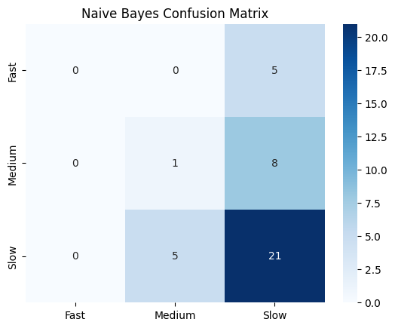

1. **K-Nearest Neighbours (KNN)**
   * **Best K = 18** (tuned using cross-validation).
   * **Accuracy**: 65% (highest among the three models).
   * Performed perfectly on **Slow** deliveries (recall = **100%**), but completely failed to classify **Fast** and **Medium**.
   * Suggests strong class imbalance, where KNN is biased toward the majority class.

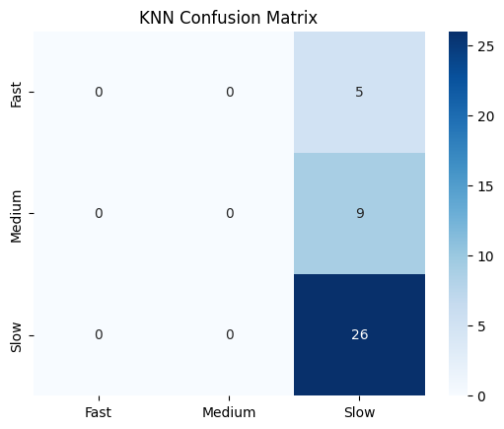

1. **Decision Tree**
   * **Best Parameters**: max_depth = 3, min_samples_split = 5.
   * **Accuracy**: 57.5%
   * Better balance compared to Naive Bayes and KNN:
     + Some correct predictions for **Medium** deliveries (recall = 11%).
     + Strong performance for **Slow** deliveries (recall = 85%).
   * More interpretable model, useful for understanding which features influence delivery times.

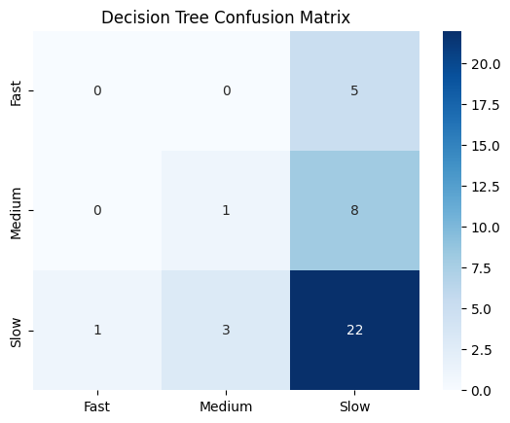

**Model Comparison**

* **KNN achieved the highest accuracy (65%)**, but its predictions were highly skewed towards the majority class (**Slow**).
* **Naive Bayes** struggled due to feature dependencies not being captured, with weak performance on minority classes.
* **Decision Tree** provided a **better trade-off**, offering both accuracy and interpretability.

Overall, while KNN appears to be the most accurate, the Decision Tree is more balanced and interpretable, making it a better candidate if fairness across all categories is a priority.

**Visual Analysis & Insights:-**

The confusion matrices highlight that both Naive Bayes and KNN struggled significantly, misclassifying most Fast and Medium deliveries. At the same time, the Decision Tree showed marked improvement, particularly in handling these minority classes. However, precision-recall metrics indicate a strong imbalance, with all models biased towards the dominant class (Slow). This points to a clear class imbalance problem in the dataset, where the prevalence of Slow deliveries skews predictions. To address this, techniques such as oversampling (e.g., SMOTE) or applying class-weight adjustments should be explored to improve recall for the underrepresented Fast and Medium categories.

From a practical perspective, the models are currently more reliable at predicting delayed (Slow) deliveries but fail to capture Fast or Medium ones accurately. In real-world deployment, this would make the system useful for flagging potential delays but less effective for identifying faster delivery cases. To enhance model reliability, collecting more representative and balanced delivery data is essential. Additionally, Decision Tree analysis offers valuable interpretability, revealing critical factors such as traffic conditions, delivery person experience, and distance that influence delivery times. These insights can guide companies in optimising resource allocation, such as assigning more experienced drivers to long-distance deliveries, ultimately reducing the frequency of delays and improving overall efficiency.